**3.Some Basic Relationships between Pixels**

**3.1.Neighbors of a pixel**

**1.N4 (p): 4-neighbors of p**.

•Any pixel p(x, y)has two vertical and two horizontal neighbors, given by

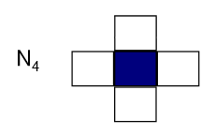 (x+1,y), (x-1, y), (x, y+1), (x, y-1)

•This set of pixels are called the 4-neighborsof P, and is denoted by N4(P)

•Each of them is at a unit distance from P.

**2.ND(p)**

•ND(p): four diagonal neighbors of p have coordinates:

|  |  |  |
| --- | --- | --- |
|  |  |  |
|  |  |  |
|  |  |  |

(x+1,y+1), (x+1,y-1), (x-1,y+1), (x-1,y-1)

**3.N8(p): 8-neighbors of p .**

•N4(P)and ND(p) together are called 8-neighbors of p , denoted by N8(p).

•N8= N4UND

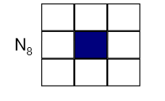•Some of the points in the N4 , ND and N8 may fall outside image when P lies on the border of image.

|  |  |  |
| --- | --- | --- |
| F(x-1, y-1) | F(x-1, y) | F(x-1, y+1) |
| F(x, y-1) | F(x,y) | F(x, y+1) |
| F(x+1, y-1) | F(x+1, y) | F(x+1, y+1) |

Fig : Sub-image of size 3x3 of 8- neighbor

**3.2.Adjacency**

•Two pixels are connected if they are neighbors and their gray levels satisfy some specified criterion of similarity.

**For example**, in a binary image two pixels are connected if they are 4-neighbors and have same value (0/1)

•Let **v**:a set of intensity values used to define adjacency and connectivity.

•In a **binary Image** **v**={1},if we are referring to adjacency of pixels with value 1.

•In a **Gray scale image** , the idea is the same, but **v** typically contains more elements,

•If the possible intensity values 0 to 255, **v** set could be any subset of these 256 values.

**Types of adjacency**

**1. 4-adjacency**: Two pixels p and q with values from **v** are 4-adjacent if q is in the set N4(p).

q

e.x: v={0,1}

p

|  |  |  |
| --- | --- | --- |
| 1 | 1 | 0 |
| 1 | 1 | 0 |
| 1 | 0 | 1 |

**2. 8-adjacency**: Two pixels p and q with values from v are 8-adjacent if q is in the set N8(p).

q

p

|  |  |  |
| --- | --- | --- |
| 0 | 1 | 1 |
| 0 | 2 | 0 |
| 0 | 0 | 1 |

e.x: v={1,2}

**3.m-adjacency(mixed):**two pixels p and q with values from **v** are m-adjacent if:

* q is in N4(p) , OR
* q is in ND(P)and The set N4(p) ∩N4(q) has no pixel whose values are from **v** (No intersection).

•Mixed adjacency is a modification of 8-adjacency.

e.x: v={1}

|  |  |  |
| --- | --- | --- |
| 0a | 1b | 1c |
| 0d | 1e | 0f |
| 0g | 0h | 1i |

Sol:

1. q is in N4(p):

b & c are m-adjacent

1. q is in N4(p):

b & e are m-adjacent

3- q is in ND(P)and The set N4(p) ∩N4(q) has no pixel whose values are from **v** (No intersection).

e & i are m-adjacent

1. q is in ND(P)and The set N4(p) ∩N4(q) has no pixel whose values are from **v** (No intersection).

e & c are NOT m-adjacent







Fig.(a) Fig(b) Fig(b)

8- adjacency m-adjacency

**3.3. Path**

A digital path (or curve) from pixel p with coordinate (x,y)to pixel q with coordinate

(s,t) is a sequence of distinct pixels with coordinates

(x0, y0), (x1, y1),..., (xn, yn),

where

(x0, y0)=(x,y),

and (xn, yn)=(s,t)

And (xi, yi)is adjacent pixel (xi-1, yi-1)for 1≤ i ≤n,

In this case, n is the length of the path.

•If (x0, y0)=(xn, yn):the path is closed path.

•We can define 4- ,8- , or m-paths depending on the type of adjacency specified.

**Example**

Consider the image segment shown in figure. Compute length of the shortest-4, shortest-8 & shortest-m paths between pixels p& q where,

v={1,2}

|  |  |  |  |
| --- | --- | --- | --- |
| 4 | 2 | 3 | 2q |
| 3 | 3 | 1 | 3 |
| 2 | 3 | 2 | 2 |
| P2 | 1 | 2 | 3 |

SOL:

1- shortest-4path

|  |  |  |  |
| --- | --- | --- | --- |
| 4 | 2 | 3 | 2q |
| 3 | 3 | 1 | 3 |
| 2 | 3 | 2 | 2 |
| P2 | 1 | 2 | 3 |

**So ,path does not exist**

2- shortest-8path

|  |  |  |  |
| --- | --- | --- | --- |
| 4 | 2 | 3 | 2q |
| 3 | 3 | 1 | 3 |
| 2 | 3 | 2 | 2 |
| P2 | 1 | 2 | 3 |

**So,shortest-8path =4**

3- shortest-m paths

|  |  |  |  |
| --- | --- | --- | --- |
| 4 | 2 | 3 | 2q |
| 3 | 3 | 1 | 3 |
| 2 | 3 | 2 | 2 |
| P2 | 1 | 2 | 3 |

**So, shortest-m path =5**

**3.4. Connectivity**

Pixels are said to be connected if there exists a path between them .

•Let S represent a subset of pixels in an image,

Two pixels p and q are said to be connected in S if there exists a path between them.

Consisting entirely of pixels 'S'.

For any pixel p in S , the set of pixels that are connected to it in S is called a **connected** **component** of S .

**3.5. Region**

• Let **R** to be a subset of pixels in an image, R is called a region if every pixel in R is connected to any other pixel in R.

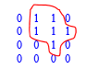.

Two regions, Ri and Rj are said to be adjacent if their union forms a connected set. Region that are not adjacent are said to be **disjoint.**

We consider 4-and 8- adjacency when referring to regions,

EX1 : Below regions are adjacent only if 8-adjacency(connectivity) is used.

|  |  |  |
| --- | --- | --- |
| 1 | 1 | 1 |
| 1 | 0 | 1 Ri |
| 0 | 1 | 0 |
| 0 | 0 | 1 |
| 1 | 1 | 1 Rj |
| 1 | 1 | 1 |

4-path between the two regions does not exist, (so their union is not a connected set).

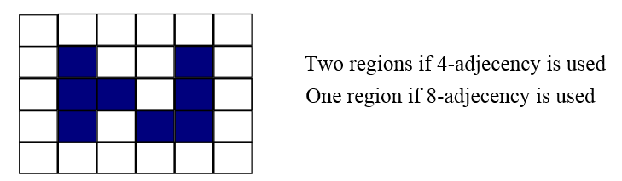EX2:

**3.6. Boundary (border)**

Boundary (border or contour) of a region R is the set of points that are adjacent to points in the complement of R (another way: the border of a region is the set of pixels in the region that have at least are background neighbor).

**Ex :**The circled point is part of the boundary of the 1-valued pixels only if 8-adjacency between the region and background is used

